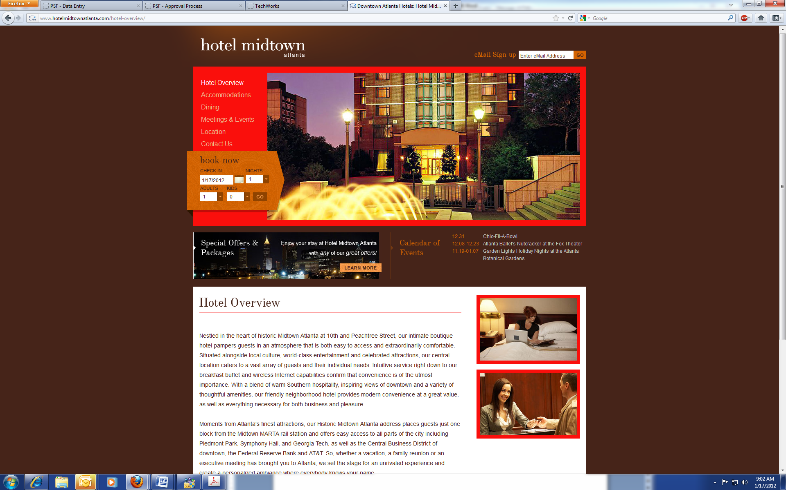
125 10th Street NE
Atlanta, Georgia, 30309, USA.
Phone: 404 873-4800
Fax: 404 870-1530
Toll free: 1-877-873-7829

Please use this form if third party expenses are to be charged to The Coulter Department of Biomedical Engineering. Be sure to provide all the information requested below to ensure prompt processing of your request. Sign and date the completed form before submission and email to: wstory@hotelmidtownatlanta.com

PO Number: ___________________ (This number must be referenced on the folio to expedite processing)

Direct Bill AR Number: __GATECH19_______________________

College/School: ________Biomedical Engineering____________

Guest Information:

Guest Name: ______________________________________________________________

Phone Number: _________________Fax or alternative number: _______________________

Confirmation Number: _____________________________________

Arrival Date: ____________________ Departure Date: ___________________

Rate Information and Approved Charges

Room rate:* ____________ Number of nights: ______
*(Final bill will reflect tax exempt status)

□ Room & Tax Only

I certify that all information is complete and accurate. I hereby authorize HOTEL MIDTOWN to collect payment for all charges as indicated in the Rate Information and Approved Charges section of this form by processing to the DIRECT BILL number listed above. Charges must not exceed __________ for the entire stay/event. I understand that a new form will be completed if guest wishes to extend his/her stay. I certify that am I authorized signer of the credit card listed above.

Requestor’s Name: (printed) ___________________________Email Address: _____________________

Signature: _________________________________________Date:_______________________________

